Barrier Option with Rebate Price Derivation by PDE Method

Yuxiao Cheng

Ruocheng Zhang

New York University

Tandon School of Engineering

Class: FRE 6233 Option Pricing

Instructor: Roza Galeeva

Dec.20th 2019

Contents

1. Introduction 3

2. Assumptions and set-ups 3

3. Derivation of option prices 4

3.1 Down-and-out call 4

3.2 Down-and-in option and extensions 5

3.3 Derive the final formula for barrier option 6

3.4 Treat Rebate as a digital option 9

3.5 Derive the final formula for barrier option with Rebate 10

4. Model Check 10

4.1 Monte Carlo Simulation 11

4.2. Check with Extreme Case 12

5. Relationship between Option and Moneyness 12

5.1 Relationship between Price and Moneyness 13

5.2 Relationship between Delta and Moneyness 13

5.3 Relationship between Price and Changing Strike 16

5.4 Relationship between Price and Changing Barrier 18

6. Delta Hedging & Price Comparison 19

6.1 Delta Hedging 19

6.2 Price Comparison 20

7.Conclusion: 21

Appendix 24

# 1. Introduction

In this paper, our main task is to solve the price of **Down-and-out call option with rebate** and **Down-and-in put option with rebate** using PDE method.

In part I, we illustrate what are the assumptions and set-ups for this report.

For part II, we derive the price formula of barrier options first from simple vanilla option, and use reflection method for simple Down and out barrier option, then extending the formula to all barrier options by taking the strike price K and the barrier X into consideration. The target we have here is the pricing formula for down-and-out call with rebate and down-and-out put with rebate, so we have also derived the formula for European digital call and put with barrier. We replicate the value of barrier option with rebate by constituting the portfolio of normal barrier option and European digital call and put with barrier.

For part III, we plot the price of Down-and-out call and Down-and-in put against moneyness and have made a detailed illustration for the insight

In part IV, we price the option using Monte Carlo simulation to double check the validity of our deriving formula, and in this case, we just check down-and-out call with rebate and Down-and-in put with rebate.

For part V, we calculate the delta by using numerical method and a single stock is picked to examine the profit and loss of our delta hedging strategy.

# 2. Assumptions and set-ups

The four basic forms of the path dependent barrier option are down-and-out, Down-and-in, up-and-out, and up-and-in. That’s to say we only have the right to exercise the option if the stock price S does not hit the barrier X. The barrier is set above or below the asset price at the time the options is created. They are often called know-out, knock-in options.

Consider one down-and-out call option with rebate, in addition to the right to exercise the option if the stock price never hits the barrier, the owner of the option could also get a fixed amount of money R at the expiry time T if the stock price ever hit the barrier. When deriving the price of such barrier options with barrier, we have the following assumptions:

* The underlying asset price follows Geometric Brownian Motion
* The volatility and the risk-free rate are constant and known but not stochastic
* The underlying asset pays no dividends and there are no transaction costs or taxes
* To avoid trivialities, we assume that the initial asset price S(0) is above the barrier X for a down-and-out call option and Down-and-in put option.

# 3. Derivation of option prices

## 3.1 Down-and-out call

We consider down-out call option as an example. Firstly, we have the equation

S is the stock price.

It also has boundary condition, X is the barrier price, K is strike price.

Then we consider the image solution of

And we can have the formula:

**Proof:**

Then satisfies the heat equation, and we know that based on reflection principle, the image solution relative to x=x0 equals to

And replacing x by is equivalent to replacing S by and it is still the solution of PDE. Then the image solution of V relative to the barrier X equals to

After we get the value of image solution, we consider the PDE form satisfying this condition

f(S) is the payoff function at time T. (It is max(S-K,0) for call option.) This is just an option where the payout at expiry is nothing if the asset price finishes below the barrier level, and the standard payout f(S) if above. Since we do not plug in the payoff function in this part, **we will not talk about the relationship between strike and barrier here**. And the solution of Down-out option PDE we want is equation (4) plus the boundary condition.

Then we can write the Down-out option price as

**Proof**:

Firstly, both satisfiy the PDE, which is equation (1), then also satisfies Equation (1)

Secondly, since , satisfies the Equation (2)

Finally, we just simplify the value of

It satisfies solution equation (3), so we can write price of Down-out option in equation (5)

## 3.2 Down-and-in option and extensions

Actually, we find that the difference between is the active domain and the form of payoff function. Then if we check out the down-out-option and up-and-out option, we can find the difference between them is only the active domain (if we assume their payoff function is the same). The active domain for down-out-option is S>X and the active domain of up-and-out option is S<X. Then if we take image solution of one option, we can get this equation

Combining this kind of parity and the parity between in option and out option, we can get four equations:

These four equations will help us get the option price we want as well as extend to other situations.

## 3.3 Derive the final formula for barrier option

Since we have already derived the equation (5), our main task changes into finding the value of and and .

And in this part the **relationship between strike and barrier price** will matter a lot.

Firstly, we define

And we know that both vanilla call option and put option can be written in same form as equation (4)

And

Secondly, we derive the expression of .

We plug in the payoff function of call option and put option into equation (4) and the result is

And

Here we can find there are two active domains for , so we need to consider the relationship between strike and barrier to determine the final formula of it.

And their relationship is:

So, we can find solutions for

And

Let me explain what is. Its payoff becomes compared to vanilla call option with payoff

So, in Black Scholes model, its formula is

So back to our question, the price of down-out call option is **(we assume K >X)**:

And the price of down-in put option is **(we assume k>X):**

**The form of price of all other options is in the appendix**

So, after we plug it in into the black Scholes model, we can get the value of Down-and-out call and Down-and-in put

Down-and-out call:

Down-and-in put:

## 3.4 Treat Rebate as a digital option

Then we need to care about the rebate, actually the rebate for Down-and-out-call and Down-and-in-put are both related to an American digital put option with payout at expiry.

And we can see this American digital put option as a European digital put option with a barrier.

For Down-and-out-call option with rebate, the corresponding rebate equals to a **European digital put option with barrier** (We can firstly assume the Rebate is 1). The effect of this option is that if the stock price falls below the barrier, it will pay 1 dollar at expiry.

For Down-and-in-call option with rebate, the corresponding rebate equals to minus a European digital put option with barrier. We call this situation **anti-European digital put option with barrier**. The effect of this option is that if the stock price is always larger than the barrier, it will pay 1 dollar at expiry.

And in this case, there is no strike price, the only barrier we need to consider is X, which is the same value as previous part.

Then we consider the anti-European digital put option with barrier, it satisfies these condition

It also has boundary condition, X is the barrier price

Then solution of anti-digital-put is

And the reason is it has the same form as down-out-call option (see equation (1)(2)(3))

So, the price of digital put option is

## 3.5 Derive the formula for only the Rebate

Here we derive the formula for rebate part only. For the **Down-and-out call** with rebate R, the rebate equals to

For the **Down-and-in-put option** with rebate R, the rebate equals to

## 3.6 Derive the final formula for barrier option with Rebate

So, the final price of Down-and-out-call with rebate R is equal to the sum of down-out-call option and R share of digital put option with same barrier

The final price of Down-and-in-put with rebate R is equal to the sum of down-in-put option and R share of anti-digital-put option with same barrier

# 4. Model Check

We assume that we have the following input information:

r = 0.02

S=50

K=50

X=45

T=1

Rebate=3

Where stands for volatility, r is the risk-free rate, S is the current underlying price, K is the strike price, X is the barrier price, and T is the time to maturity, and Rebate is the amount the owner will have when the underlying price hits the barrier.

# 4.1 Monte Carlo Simulation

We only show the code of Down-and-out call option with rebate since the two are similar.

**Monte Carlo simulation for Down-and-out call**

**def Monte_doc(X, K, S, T, sigma, r, Rebate):**

**np.random.seed(1234)**

**result = 0**

**m = 365**

**number = 15000**

**for i in range(0, number):**

**indicator = 1**

**Snew = S**

**for j in range(0, m):**

**Snew = Snew * math.exp(**

**(r - sigma * sigma / 2) * (T / m) + sigma * math.sqrt(T / m) * np.random.normal(loc=0, scale=1, size=1))**

**if Snew < X: indicator = 0**

**if indicator == 1: result = result + max(Snew - K, 0)**

**if indicator == 0: result = result + Rebate**

**result = result / number**

**result = result * math.exp(-r * T)**

**return result**

The setting of parameters is always the same as before and we take 15000 samples and assume there are 365 days in one year.

The result shows that:

Option price by Monte Carl for Down-and-out call with rebate: 1.5944

Option price by deducted formula for Down-and-out call with rebate: 1.6047

Option price by Monte Carl for Down-and-in put with rebate: 2.9674

Option price by deducted formula for Down-and-in put with rebate: 2.9669

The error is quite small. Thus, our model has been proved right.

# 4.2. Check with Extreme Case

**Extreme case checking**

**print("Option price for down-out-call with rebate in extreme case: " + str(Doc_with_rebate(S, K, r, sigma, T, S-10, Rebate)))**

**print("Option price of vanilla call: " + str(Call(S, K, r, sigma, T)))**

**print("Option price for down-in-put with rebate in extreme case : " + str(Dip_with_rebate(S, K, r, sigma, T, S-0.001, Rebate)))**

**print("Option price by vanilla put: " + str(Put(S, K, r, sigma, T)))**

In this part, we check our model by using very low barriers, when option becomes vanilla.

From the code above, for the down-out-call option with rebate, we choose the barrier as stock price minus 10. This is a very low barrier since our volatility is only 5 percent. And for down-in-put option with rebate, we use the barrier as stock price minus 0.001, which means it definitely will reach the barrier and knock in and become vanilla put option. And these are our results:

Option price for down-out-call with rebate in extreme case: 1.5603499

Option price of vanilla call: 1.5603457

Option price for down-in-put with rebate in extreme case: 0.5717

Option price by vanilla put: 0.5702

We can find that the difference is very small. Thus, our model has been proved right.

# 5. Relationship between Option and Moneyness

First, we define moneyness , now we are going to see how option prices and their delta change with moneyness. And we will also check how option prices change with the strike price and barrier price.

## 5.1 Relationship between Price and Moneyness

In this part we try to explore the prices of Down-and-out call and Down-and-in put with moneyness.

**Figure 1: Price with Moneyness**

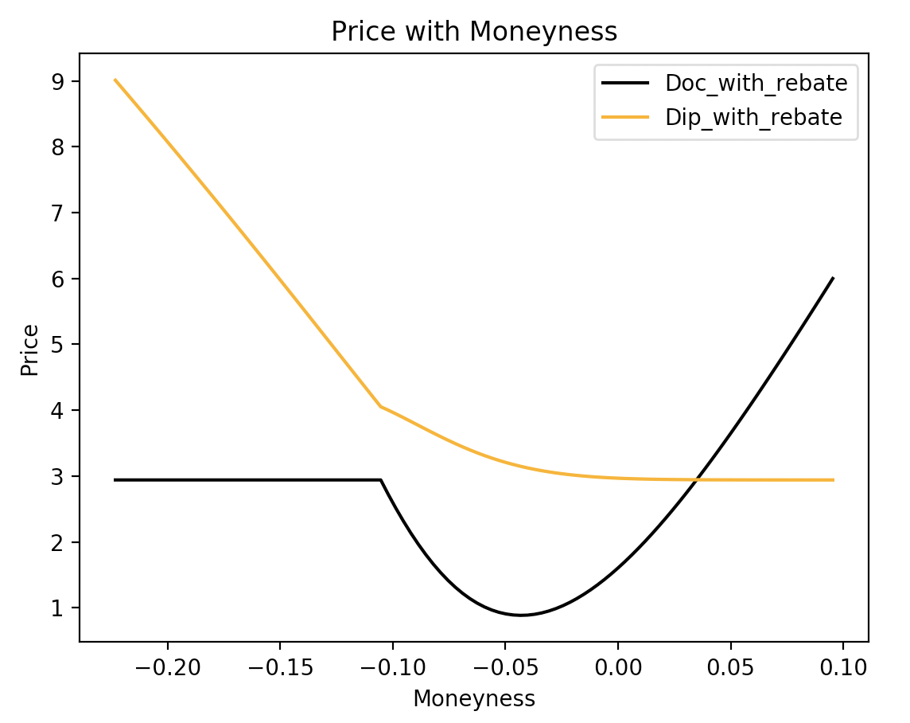

The graph is quite interesting.

First we could see from the black curve of Down and out call with rebate that it only has the rebate value which is 3 dollars as we defined above before the moneyness -0.10 which is our underlying price of 45, which corresponds to our intuition because the stock now is below the barrier and we are out and get the rebate (its present value). After -0.10, we see the value first goes down and then goes up. This is caused by 2 factors. The first factor is the value of our rebate option. When the underlying price is above 45 (the moneyness is above -0.10), our rebate option still has value because the closer the underlying approaching to 45, the greater the possibility we will have the rebate. As the moneyness goes up, we also expect that the value of the rebate option decays because the possibility that we will get rebate is less and less. However, the second factor, the value of the down-and-out option pulls the price back because as the moneyness goes greater, the possibility that we will be out is diminishing. Notice that the curve is concave around -0.10 to -0.15, which means the closer as the underlying goes to the barrier, the possibility that we will have rebate increase more rapidly, thus the value grows more quickly.

Next, we see the elegant curve of Down-and-in put. When the moneyness is below -0.10, the curve is just a line because the when the stock price is below the barrier, we are in and the option just becomes a vanilla put. From the right side, -0.10 to 0.00, the owner get the decreasing value of rebate (more likely to lose the rebate if in) and increasing value of Down-and-in put (more likely to in) , however when we are in we will be more likely to get more money than the rebate, that’s why the curve is increasing from 0.00 to -0.10.

## 5.2 Relationship between Delta and Moneyness

**Calculation for delta**

**def delta_of_doc(S,K,r,sigma,T,X,Rebate):**

**delta=[0]*100**

**epsilon=0.1**

**for i, j in enumerate(np.linspace(0,epsilon,100)):**

**larger=Doc_with_rebate(S+j,K,r,sigma,T,X,Rebate)**

**smaller=Doc_with_rebate(S-j,K,r,sigma,T,X,Rebate)**

**value=(larger-smaller)/(2*epsilon)**

**delta[i]=value**

**return np.mean(delta)**

**def delta_of_dip(S,K,r,sigma,T,X,Rebate):**

**delta=[0]*100**

**epsilon=0.1**

**for i, j in enumerate(np.linspace(0,epsilon,100)):**

**larger=Dip_with_rebate(S+j,K,r,sigma,T,X,Rebate)**

**smaller=Dip_with_rebate(S-j,K,r,sigma,T,X,Rebate)**

**value=(larger-smaller)/(2*epsilon)**

**delta[i]=value**

**return np.mean(delta)**

Delta for call and put are and since the analytically Delta is too difficult for these two kinds of option so we calculate the numerical delta by central finite difference method

Where

In this situation the setting is the same as question 1. And as the code above said, we take 100 points around S to calculate the delta and take average of them to get the final one we want

**Figure 2: Delta with Moneyness**

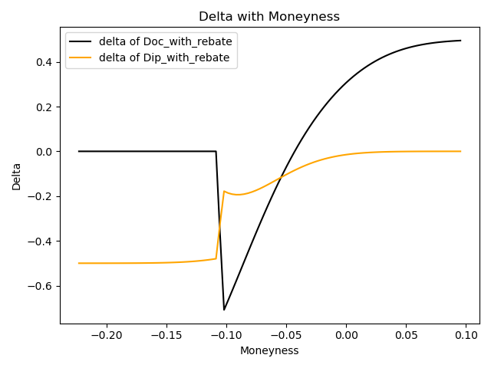

We take range of price from S-10 to S+5 since we want to know the behavior of this option when it’s under barrier.

We first see the down-out call option with barrier in the plot with blue line. When the stock price is under barrier, the alpha will keep 0 since the option price will equal to the discount value of rebate.

After the stock is larger than the barrier, we can see that the delta of down-out call will quickly fall to negative value because it has chance to not touch the barrier and at the same time the profit from call option is low. But when stock price keeps increasing, the alpha will increase to positive value since the stock price is larger and the call option has larger probability to earn money and the profit is larger than rebate. And the price will also keep increasing.

We then check the down-in put option with barrier in the plot with orange line. Actually, the orange line is always below 0 since it’s not good for put option when price is increasing. When the stock price is under the barrier, the option will knock in and automatically change into a normal put option, the price of option will decrease, but the speed is the same, which means the alpha will keep the same.

But with the increase of price, there will be a jump to a larger delta. The reason is that the stock has the opportunity to not reach the barrier and the option will give rebate as compensation.

So, the speed of decreasing is slowing down. It will become much closer to zero when stock price is much larger than barrier, which shows the effect of rebate is already done and it’s very hard to knock in for this option for higher stock price, the price of option will approach to rebate value gradually and alpha will approach to zero gradually.

## 5.3 Relationship between Price and Changing Strike

**Figure 3: Price with changing strike**

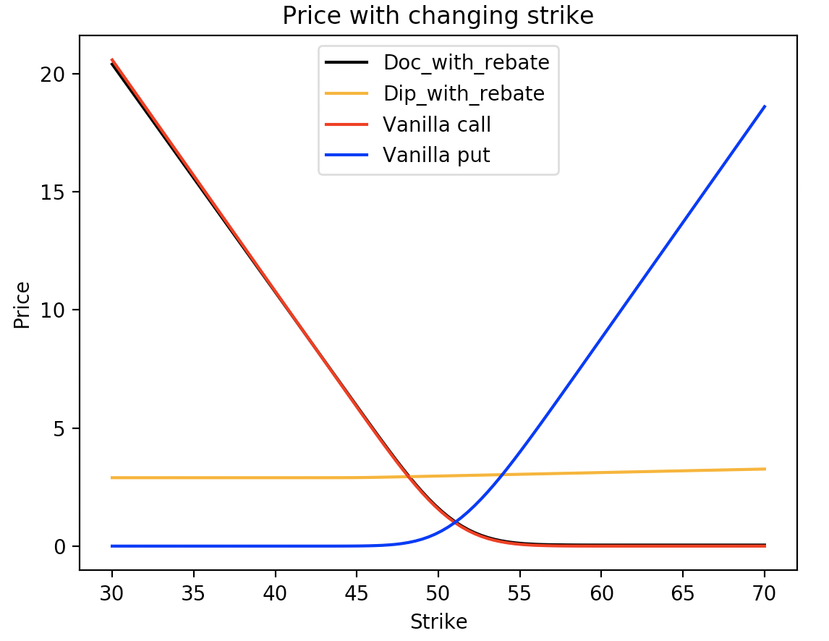

Now we fix the barrier and other inputs as we used before and see what could happen for the price of the above four options.

First we see the Down-and-in put with rebate. Initially it has very low value because we fix the stock price at 50 which is 5 dollars more than its barrier 45, the possibility that we will in is very low so it has such low value which is around 3 dollars, the rebate. Before 45 (K<X) it’s just a vanilla put because it pays nothing if the price is above the strike and when it pays it must have hit the barrier. After 45, we see the rising price of Down-and-in put with little increments.

Next, we focus on Down-and-out call with rebate. Apparently, its value is super close to the vanilla call because the possibility that the price will fall below the barrier is very low.

However, if we make the process more interesting, fix X=49 which is very close to current underlying price 50, the graph is as below,

**Figure 4: Price with changing strike**

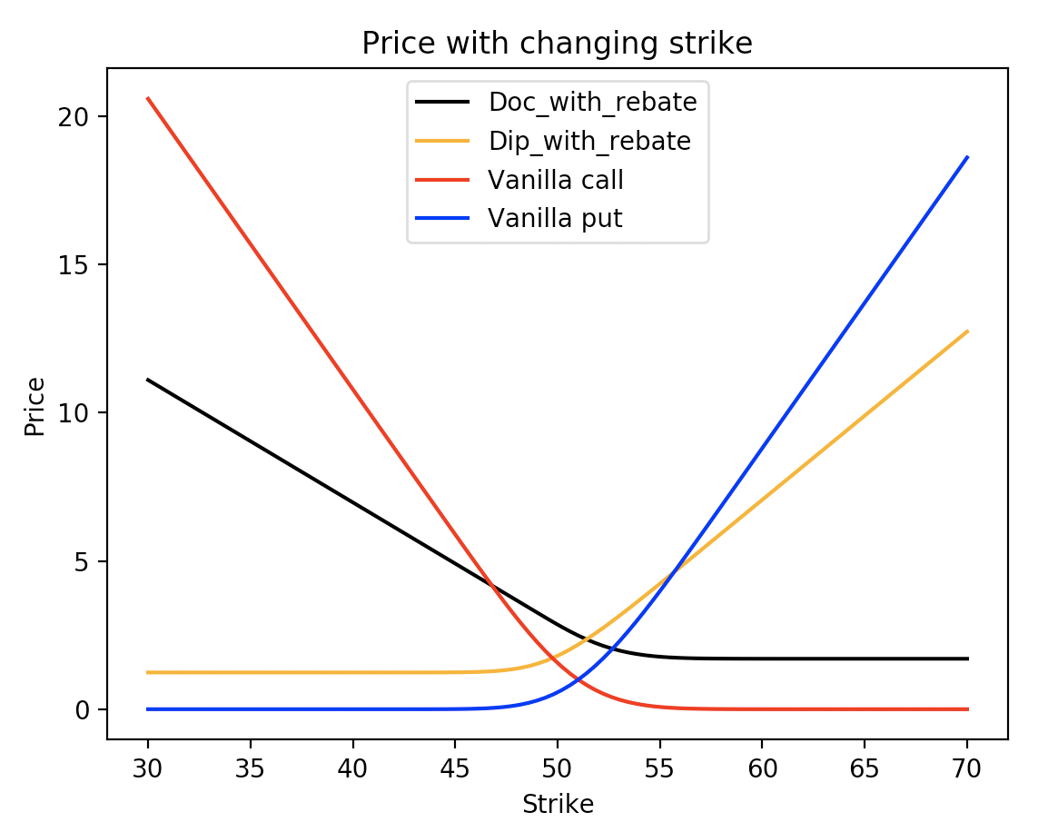

First the price of Down-and-out call with rebate falls a lot comparing to the graph before because there is high chance that it would default so the payoff would be much less.

The price of Down-and-out call with rebate and vanilla call intersects at a point before 49, this is because although the pay-off of two call decreases to 0 as K increases, the rebate is likely to be activated here so the price of Down-and-out call would converge to the rebate value.

For the Down-and-in put with rebate, because the chances of getting in is very big, it acts more robustly in this situation. The price change is less sensitive for the barrier option in this case because it has chances to out and in as well as the existence of the rebate.

## 5.4 Relationship between Price and Changing Barrier

Also used the inputs we used at the very beginning of this section, the plot is as below,

**Figure 5: Price with changing strike**

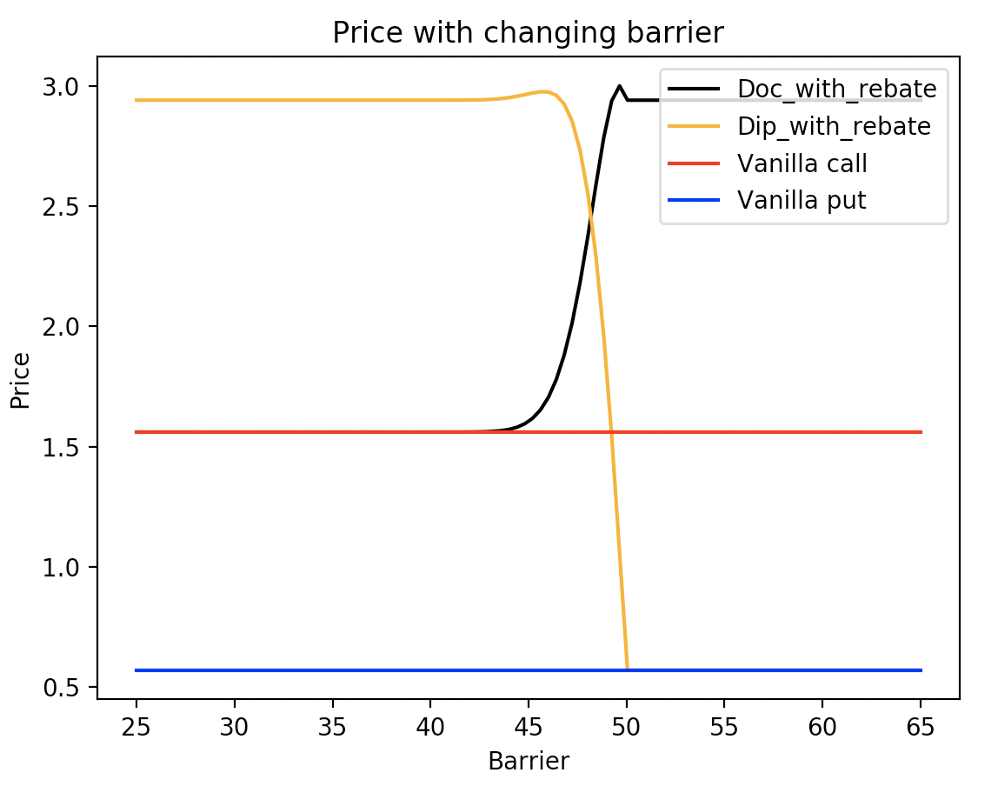

This graph is easier to interpret. Before 45, for the Down-and-out call with rebate, the chance that the rebate will be activated is so low that the price of two option is almost the same, in other words, it’s just a like a vanilla call but with little bit less value cause there is still extreme cases which it would default . As the barrier approaching to the current underlying price, the value of Down-and-out call with rebate rises because the rebate here, 3 dollars, is more likely to be activated. For the Down-and-in put with rebate, it’s the same story as before. The put here is less valuable than call because we have risk-free rate bigger than zero here

# 6. Delta Hedging & Price Comparison

## 6.1 Delta Hedging

In this part we choose an ETF FXI to see if we could successfully do a delta hedging using the formula we derived before.

First let’s assume the following parameters,

The test set is composed of daily adjusted closing price of FXI

from 2017-12-03 to 2018-12-02

The training set is composed of daily adjusted closing price of FXI

from 2018-12-03 to 2019-12-03

r = 0.02

S is daily adjusted closing price of the underlying

K is the first adjusted closing price of our test set

X(Barrier) is the minimum value of the training set -2

T=1

Rebate=10

We use numerical delta to replicate our delta here because the analytical delta is too hard to derive.

The formula for delta and PnL is as below:

Numerical Delta: =

Daily PnL:

The intuitive explanation for this PnL is, we sell make as our portfolio and we long 1000 everyday.

**Figure 6: Profit and loss for delta hedging**

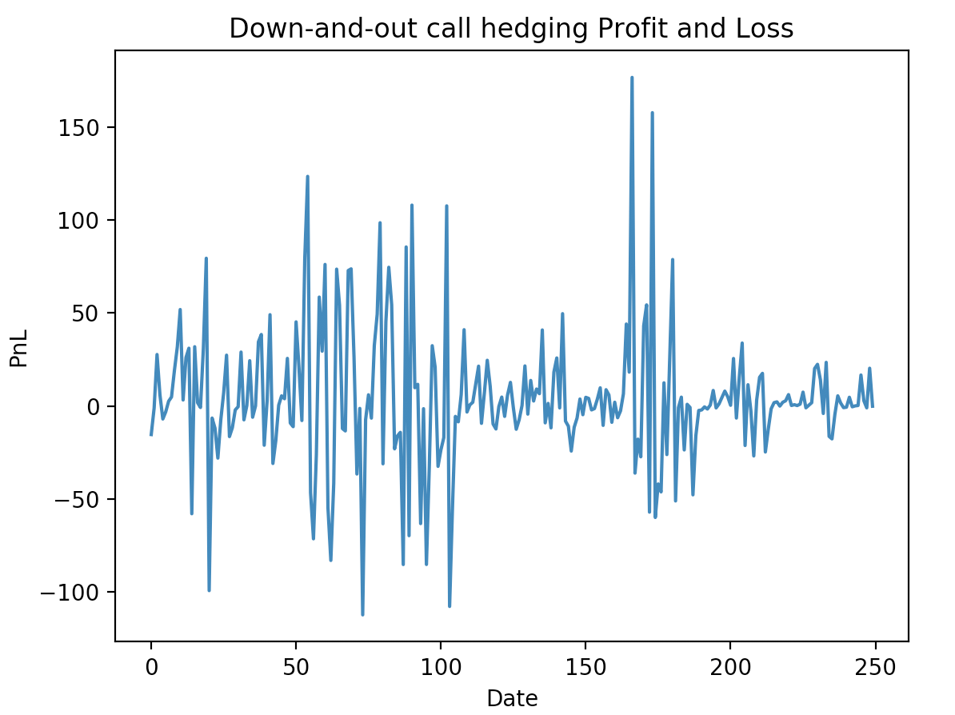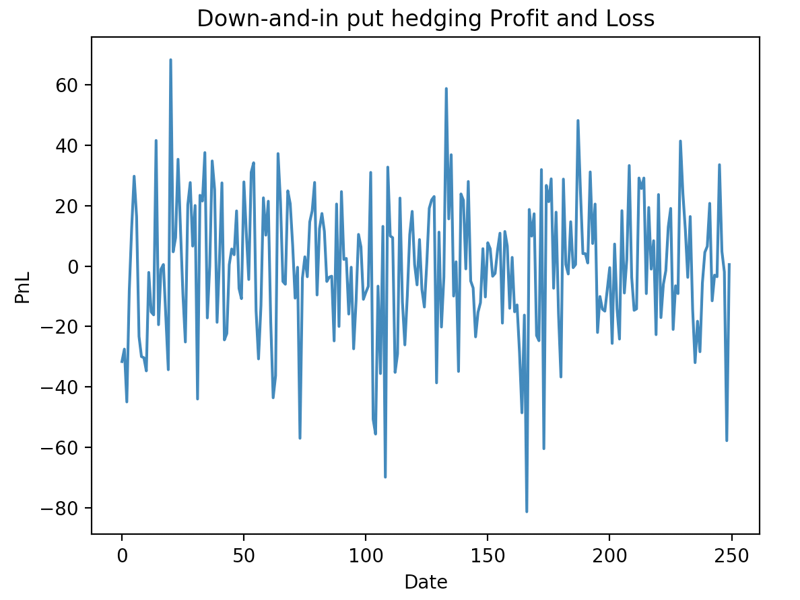

From the graph we see that the profit and loss is hedged well. There might be some date whose absolute value of PnL is greater than 100, that’s because there is a huge price jump in that date. The final sum of PnL is 1016 for Down-and-out call and -135 for Down-and-in put which is within our expectation.

## 6.2 Price Comparison

**Figure 7: Price comparison with vanilla option**

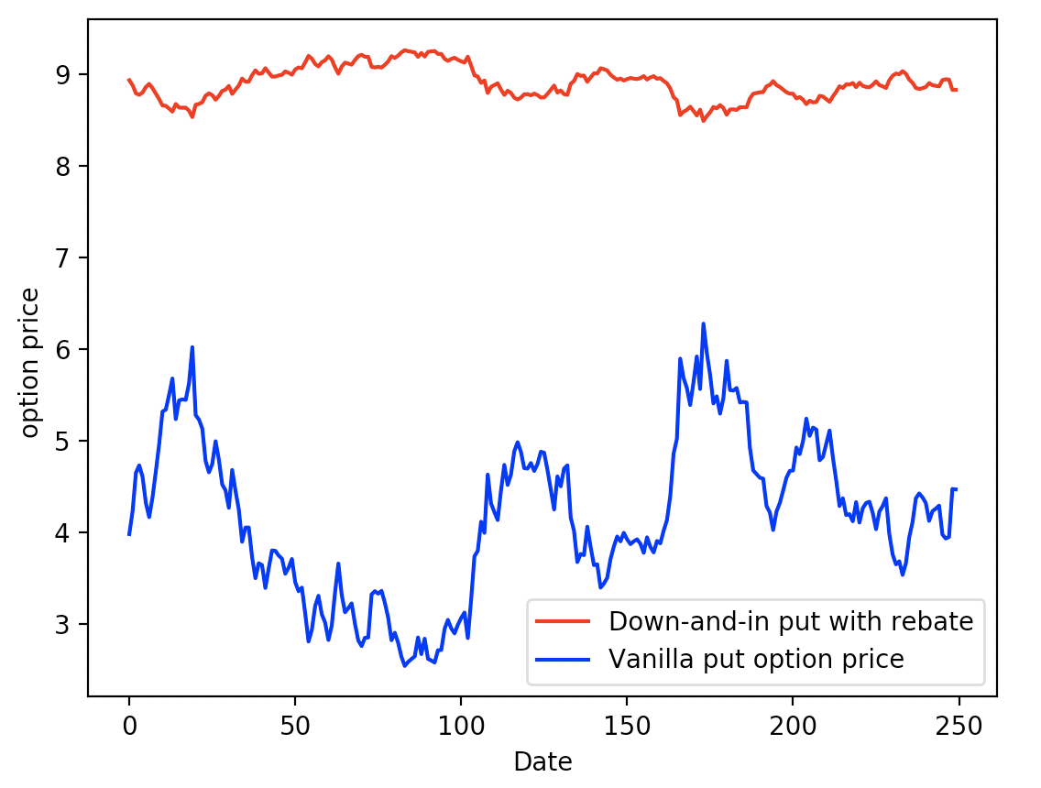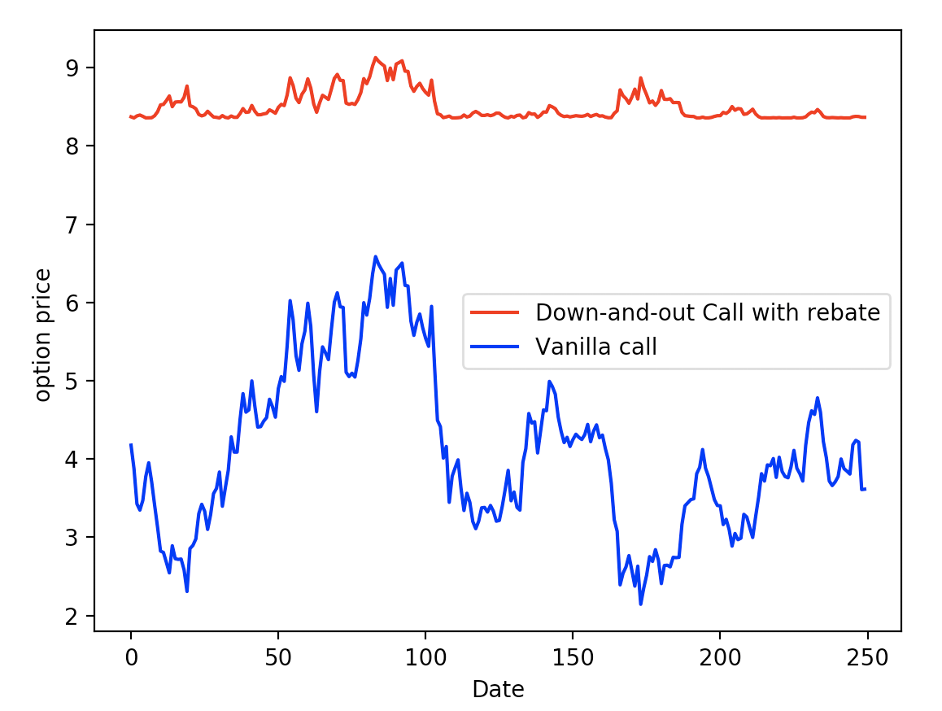

After comparing the Down-and-in put option with rebate with the vanilla put option and comparing the Down-and-out call option with rebate with the vanilla call option of the same data set we used above, we can find that the exotic option will have larger price since it has a rebate to compensate it and the price depends on the amount of rebate a lot. And the volatility of the option price will become much smaller also because of the existence of rebate, which offset the drawback of barrier. It can offer stable profit to the option holder. So, it’s reasonable to have higher price for these exotic options.

# 7. Conclusion:

**In our project, we first price the value of down-and-out call option with rebate and down-and-in put option. The formula is as follows:**

where

**Then, we check our formula in test, we firstly use Monte Carlo Method**

We conduct Monte Carlo simulation to check our option price and we compare our analytical option price with the Monte Carlo price given. The result shows that the differences of the two values are very small, which proves our formula:

Option price by Monte Carl for Down-and-out call with rebate: 1.5944

Option price by deducted formula for Down-and-out call with rebate: 1.6047

Option price by Monte Carl for Down-and-in put with rebate: 2.9674

Option price by deducted formula for Down-and-in put with rebate: 2.9669

**The second check is to consider the extreme case**

Option price for down-out-call with rebate in extreme case: 1.5603499

Option price of vanilla call: 1.5603457

Option price for down-in-put with rebate in extreme case: 0.5717

Option price by vanilla put: 0.5702

And we can see that the difference is still very small. So, we can believe our formula is right and we can continue further research.

**Then we deal with the relationship between the price with moneyness, strike and barrier as well as the relationship between delta and moneyness. The details of result are already shown above.**

(Notice that the graph at the left bottom corner the barrier is different, it’s 49)





**After that, we choose ETF FXI from 2018.12.3 to 2019.12.13 to implement our formula and calculate daily PnL and plot it based on the given portfolio.**

The result is:



And it shows that our portfolio hedges very well.

**Finally, we compare Down-and-in put option with rebate with the vanilla put option and compare the Down-and-out call option with rebate with the vanilla call option of ETF FXI from 2018.12.3 to 2019.12.13 and plot them**



And we can see that the price of exotic options is much higher and have smaller volatility because of the existence of rebate.

# Appendix

**Table I: Price formula for different barrier options**

|  |  |  |
| --- | --- | --- |
| Option Type | Strike price K>Barrier X | Strike price K<Barrier X |
| Down-and-out-call |  |  |
| Down-and-in-call |  |  |
| up-in-call |  |  |
| up-out-call | 0 |  |
| Down-and-out-put |  | 0 |
| Down-and-in-put |  |  |
| up-in-put |  |  |
| up-out-put |  |  |

**Table II: Put European digital Rebate Price formula test by Monte Carlo method**

If not changed, S=50, X=45, K=50, T=1, Sigma=0.05, r=0.02

